Мамба

Идили

[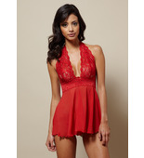](https://www.ideeli.com/store/place_order)

[RENE ROFE Sexiest Halter Chemise/G-String Set](https://www.ideeli.com/store/place_order)  
**Color:** Red  
**Size:** S

Between Oct 06 and Oct 13   
[Non-returnable](https://www.ideeli.com/store/place_order#ineligible_return)

**1**

**$15.00**

[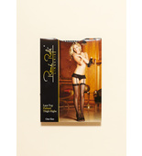](https://www.ideeli.com/store/place_order)

[RENE ROFE Lace Top Fishnet Thigh Highs](https://www.ideeli.com/store/place_order)  
**Color:** Black  
**Size:** O/S

Between Oct 06 and Oct 13   
[Non-returnable](https://www.ideeli.com/store/place_order#ineligible_return)

**1**

**$4.00**

[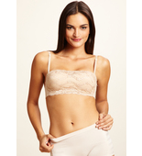](https://www.ideeli.com/store/place_order)

[RENE ROFE Lacey Temptress Bra](https://www.ideeli.com/store/place_order)  
**Color:** Nude  
**Size:** 34B

Between Oct 06 and Oct 13   
[Non-returnable](https://www.ideeli.com/store/place_order#ineligible_return)

**1**

**$7.00**

[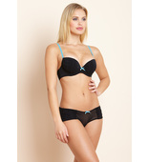](https://www.ideeli.com/store/place_order)

[RENE ROFE Ruchin' Around Push-Up Bra/Boyshort Set](https://www.ideeli.com/store/place_order)  
**Color:** Black/Blue Atoll  
**Size:** 32A/S

Between Oct 06 and Oct 13   
[Non-returnable](https://www.ideeli.com/store/place_order#ineligible_return)

**1**

**$12.00**

**Итого: 38+1,7+18%)*31,5=1476руб**